**Fiscal Year 2019 First Quarter Milestone Report**

December 31, 2018

Laura Vimmerstedt, Annika Eberle, Dylan Hettinger, Danny Inman

This report serves as a first quarter milestone report for fiscal year 2019. As stated in the Annual Operating Plan, the purpose of this milestone report is to, “Identify conditions under which low TRL [technology readiness level] technologies are competitive in the current and future WTE [waste-to-energy] industry. Specific areas of investigation will focus on four areas of interest, as identified from the sensitivity analysis performed in FY18: 1)Maturity tipping point, 2)Disposal costs, 3)Financial parameters around learning, and 4)Inter-regional policy impacts.”

We report on a study that explored the impact of twelve model factors on the adoption of hydrothermal liquefaction (HTL) as a WTE technology choice for concentrated animal feeding operations (CAFOs) and publicly owned treatment works (POTWs) in California and the rest of the United States. HTL is under development—including U.S. Department of Energy research and development. The two pilot-scale projects are located in Vancouver, British Columbia and Oakland, California, and there are no commercial-scale facilities in operation.

The technology investment decision process of the WTE industry differs from that of the biofuels industry because the disposal of waste is a required function and energy production is optional for WTE facilities. Facilities such as POTWs and CAFOs are required by federal and state laws to treat and/or dispose of the biosolids (manure, sewage sludge) produced as part of their respective operations. Evaluation of investment in technologies that physically reduce the amount of biosolids to be treated balances the capital and operational investments with the avoided costs of waste disposal. Technologies that produce a marketable source of energy offer an additional revenue stream that can help to offset the capital and operational costs.

Mature WTE technologies can effectively reduce the amount of biosolids and produce energy. Based on our most recent data update (July 2018), across both CAFOs and POTWs over 350 WTE projects exist. Although the majority of CAFOs and POTWs have not invested in any WTE technology, investment in incumbent technologies (e.g., combined heat and power [CHP], compressed natural gas [CNG], electricity, pipeline natural gas [PNG]) is more likely than in less mature technologies. Even so, our model results identify scenarios under which HTL achieves modest levels of adoption. This occurs despite the main impediment to widespread adoption of HTL: its low commercial maturity level. Although important, higher commercial maturity level alone does not prompt HTL adoption.

NREL conducted an analysis to explore the development potential of HTL conversion of wastewater sludge and dairy manure to fungible bio-crude that can be converted, via upgrading, to a hydrocarbon liquid transportation fuel. The technology cost and performance assumptions for HTL are based on the nth plant design case by PNNL (2017/PNNL-27186) for biocrude from sludge (see Table 6 of that report).

To perform this analysis, we used the waste-to-energy system simulation model (WESyS), a system dynamics model that tracks WTE technological investments and energy production from landfills, POTWs, and CAFOs in two U.S. regions – California and the rest of the United States. The model represents seven technology investment options: no waste-to-energy (NoWTE), capture and flare (CF), CHP, CNG, electricity, PNG, and HTL. The first two of these do not produce energy. HTL is still under development—including U.S. Department of Energy research and development—and therefore has a lower technical readiness level than the other WTE technologies that are represented in the model.

Our objective was to identify key factors that might contribute to the successful commercial deployment of HTL. Based on our analysis, this report presents the following insights:

1. Although the various values of the twelve key input factors explored in this study generally favor the adoption of incumbent technologies, specific combinations of values lead to modest levels of HTL adoption.
2. Five factors in the analysis explain variance in HTL production; of these, two explain variance in total energy production.
3. The factors that are most important to HTL production relate to different aspects of the WTE supply chain, including WTE technology development, policy incentives, waste management costs, and expenses during construction.
4. The relative importance of these factors varies between CAFOs and POTWs.
5. Simulations with higher HTL production have higher initial commercial maturity of HTL *and* external conditions that favor HTL relative to other investment options.
6. Based on the limited factors and ranges explored, this study did not find evidence of inter-regional policy impacts on growth in HTL production.

Together, these insights show a narrow path to growth in HTL production, with certain key factors offering the most favorable conditions for HTL growth by advancing HTL technology and limiting competition from other technologies.

Key model assumptions that affect WESyS outcomes relate to capital investments, waste transportation, policies, and technology cost and performance. The fixed capital associated with each conversion option is assumed to be installed on site. WTE technology at POTWs is tracked over its life cycle such that new technology can replace retiring technology, while technology installed on CAFOs and landfills is assumed to last for the duration of the simulation, precluding replacement opportunities. The model does not include waste transportation or consolidation of waste from multiple sites. However, the model does represent policies that generate credits, including Renewable Identification Numbers (RINs), which expire after 2022; Low Carbon Fuel Standard (LCFS) credits, which expire in 2030; and Production Tax Credit Renewable Electricity Credits (PTC RECs), which are assumed never to expire. The model also represents the effects of California Senate Bill 1383, but no other California state policies that may impact WTE.

Because HTL is at a low technology readiness level, parameters relating to industrial learning are important, and we varied the level of initial commercial maturity for HTL from 0 (not commercialized at all) to 0.9 (newly commercialized), testing a range of potential initial conditions for HTL maturity.

For this study, we used a Sobol quasi-random sequence study design in which we varied twelve model factors (Table 1). The choice of factors was based on previous sensitivity analyses (FY18 Q3 and Q4) as well as our understanding of the model and the system it represents. Using this approach, the study design consisted of 195,000 simulations. After the simulations were run, we performed regression tree analysis on the results with a pruning criterion set to 0.05 (i.e., only factors that explain > 5% of the variance are included in the regression tree). We performed regression tree analysis and examined the time series of energy production by resource, energy type, and region to generate the following insights.

**Table 1. Default values and range of factors included in this analysis.**

|  |  |  |  |  |  |
| --- | --- | --- | --- | --- | --- |
| **Factor** | **Description** | **Units** | **Default** | **Low** | **High** |
| Initial commercial maturity of HTL | Sets initial maturity level for HTL. | - | 0 | 0 | 0.9 |
| RIN multiplier | Multiplied by the base value of the RIN credit, which reaches $2.50 per gallon. | - | 1 | 0 | 2 |
| Construction duration multiplier | Determines the lag time from project initiation to completion. | - | 1 | 0.33 | 1.67 |
| Disposal cost | Charge for landfilled waste. | $/tonne | 52.2 | 0 | 450 |
| PTC REC multiplier (only applicable to CHP, CNG, Elec, and PNG; other technologies have zero PTC REC) | Multiplied by the base value of the PTC REC, which reaches a maximum of $3.33 per gasoline gallon equivalent for electricity. | - | 1 | 0 | 2 |
| LCFS multiplier | Multiplied by the base value of the LCFS, which ranges from 0 to $180/tonne. | - | 1 | 0 | 2 |
| SB1383 waste influx multiplier | Multiplied by the base fraction of influx diverted from landfills because of SB1383, which ranges from 0 to 0.75. | - | 1 | 0 | 1 |
| SB1383 organic waste to POTW multiplier | Multiplied by the weight of organic waste that is diverted from landfills due to SB1383. | - | 0.95 | 0 | 0.95 |
| Seeding demo plants start time | Start year of demonstration of technology. | time | 2018 | 2018 | 2022 |
| Seeding demo plants duration | Duration of demonstration of technology. | years | 4 | 1 | 10 |
| Effect of seeding demo plants on maturity for HTL | Determines the influence of demonstration experience on maturity improvement for HTL. | - | 1 | 0 | 5 |
| AEO selector | 3-way choice between reference, high, and low oil prices scenario in the Energy Information Administration’s AEO. | - | 1 (Reference case) | 1, 2, or 3 | |

Abbreviations: HTL = hydrothermal liquefaction; RIN = Renewable Identification Number; PTC REC = Production Tax Credit Renewable Electricity Credit; CHP = Combined Heat and Power; CNG = Compressed Natural Gas; Elec = Electricity; PNG = Pipeline Natural Gas; LCFS = low carbon fuel standard; SB1383 = California Senate Bill 1383; POTW = publicly owned treatment works; AEO = Annual Energy Outlook.

**Insight #1. Although the various values of the twelve key input factors explored in this study generally favor the adoption of incumbent technologies, specific combinations of values lead to modest levels of HTL adoption.**

In this study, we varied twelve key input factors over a wide range of values using a uniform distribution for each (see Table 1 for the list of factors and corresponding parameter ranges). Because we were unable to find adequate data on the empirical distributions of these inputs, we could not estimate the probability of each set of results. However, the results of our analysis with the uniform distributions suggest that the combinations of input values that result in growth in HTL production is rare. Out of 195,000 simulations, only 16,133 (less than 10%) resulted in HTL production that was greater than zero. Figure 1 shows relative (top panel) and total (bottom panel) energy contribution by resource, region, and WTE technology.

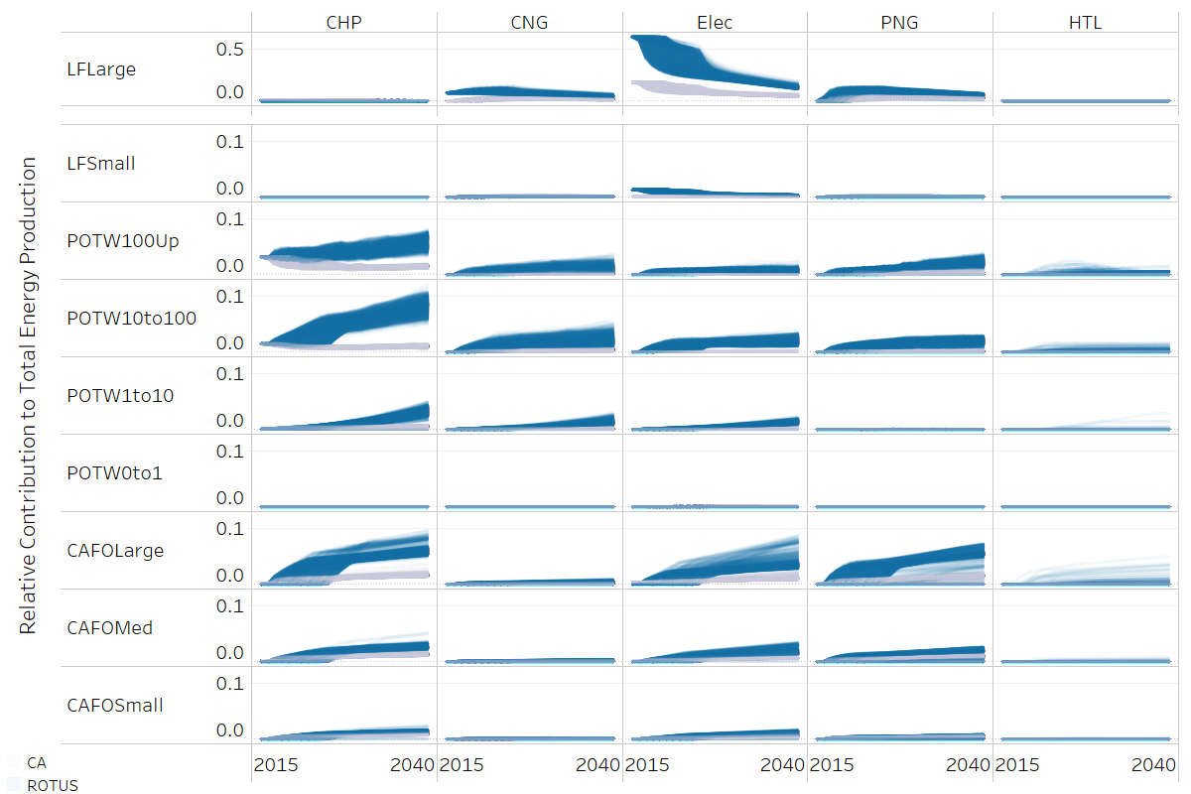

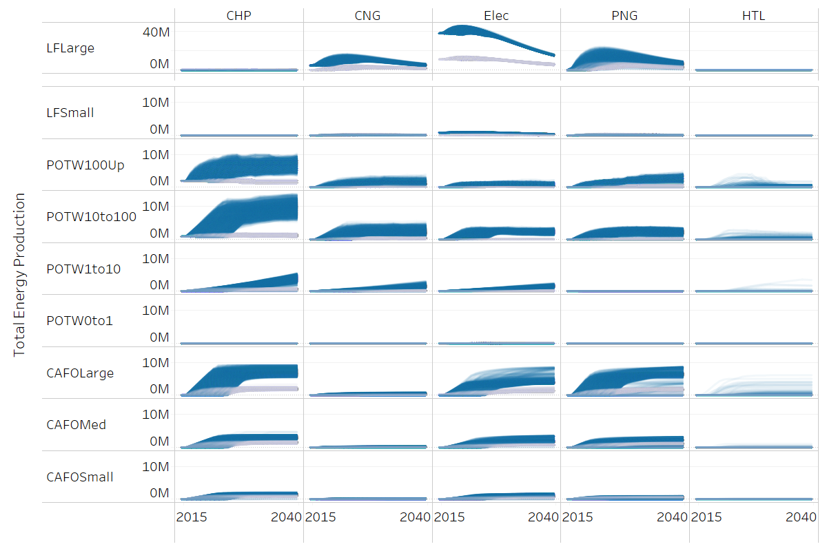

**Figure 1. Relative (top panel) and total (bottom panel) energy contribution by resource, region, and technology for cumulative energy production from WTE facilities from 2015 to 2040.** Abbreviations: CHP = Combined Heat and Power; CNG = Compressed Natural Gas; Elec = Electricity; PNG = Pipeline Natural Gas; HTL = hydrothermal liquefaction; LFLarge, LFSmall = large and small landfills; POTW100Up, POTW10to100, POTW1to10 = large, medium, and small Waste Water Treatment Plants (POTWs); CAFOLarge, CAFOMed, CAFOSmall = large, medium, and small concentrated animal feeding operations.

**Insight #2. Five factors in the analysis explain variance in HTL production; of these, two explain variance in total energy production.**

For a factor to be considered important in this study, it must, in combination with all the other factors, explain at least 5% of the total variance of the target output metric (either energy from HTL or total energy). Table 2 ranks the factors that are most important for HTL production and those that are most important for total energy production. The mechanisms by which these factors affect energy production, and the reasons for differences between HTL and Total energy production, are explored below.

|  |  |  |  |
| --- | --- | --- | --- |
| **Factor** | **Explains >5% of variance** | **…in HTL energy (Rank, 1=most important)** | **…in Total energy**  **(Rank, 1=most important)** |
| Initial commercial maturity of HTL |  | 1 |  |
| RIN multiplier |  | 2 |  |
| Construction duration multiplier |  | 3 | 2 |
| Disposal cost |  | 4 |  |
| PTC REC multiplier (only applicable to CHP, CNG, Elec, and PNG; other technologies have zero PTC REC) |  | 5 | 1 |
| LCFS multiplier | no |  |  |
| SB1383 waste influx multiplier | no |  |  |
| SB1383 organic waste to POTW multiplier | no |  |  |
| Seeding demo plants duration | no |  |  |
| Seeding demo plants start time | no |  |  |
| Effect of seeding demo plants on maturity for HTL | no |  |  |
| AEO selector | no |  |  |

**Table 2. Relative importance of factors for cumulative HTL energy production and total energy production from 2015 to 2040.**

Note: The “Factor” column lists each of the factors that were varied in this analysis. These were selected based on previous variance-based sensitivity analysis. The remaining columns show the relative importance for HTL and total energy production of each of the factors that explains more than 5% of the variance, in combination with other factors. Abbreviations: HTL = hydrothermal liquefaction; RIN = Renewable Identification Number; PTC REC = Production Tax Credit Renewable Electricity Credit; CHP = Combined Heat and Power; CNG = Compressed Natural Gas; Elec = Electricity; PNG = Pipeline Natural Gas; LCFS = low carbon fuel standard; SB1383 = California Senate Bill 1383; POTW = publicly owned treatment works; AEO = Annual Energy Outlook.

**Insight #3. The factors that are most important to HTL production relate to different aspects of the WTE supply chain, including WTE technology development, policy incentives, waste management costs, and expenses during construction.**

The factors that are most important to HTL production relate to WTE technology development (initial commercial maturity of HTL), policy incentives (the RIN multiplier and the PTC REC multiplier), the waste management costs (disposal cost), and expenses during construction (construction duration multiplier). Figure 2 shows where these factors fall on a generic diagram of the WTE supply chain. Table 3 shows each factor with an explanation of the mechanism by which it influences HTL production and the related default values from the model.

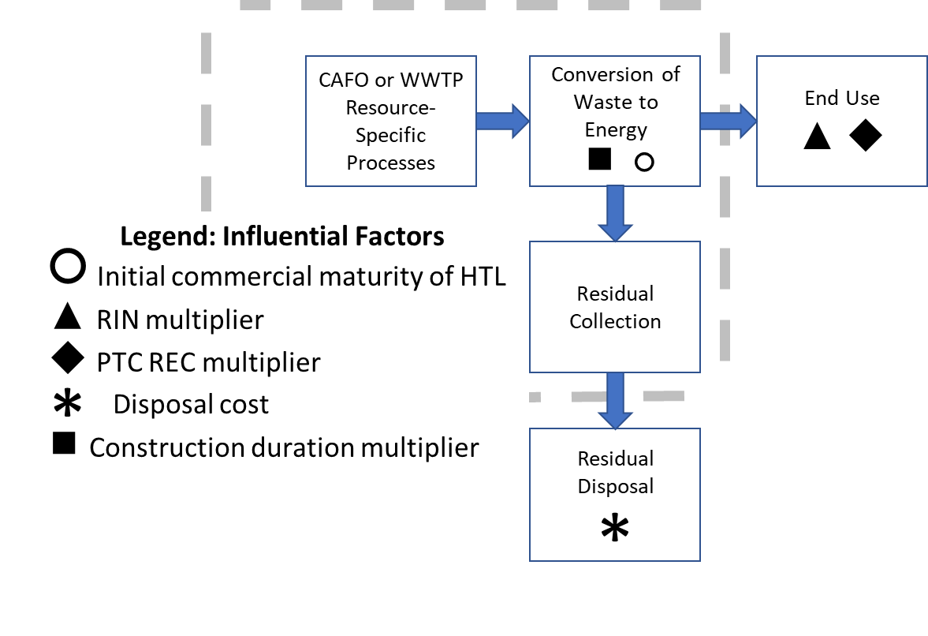

**Figure 2. Position of influential factors in supply chain.** Abbreviations: CAFO = Concentrated Animal Feeding Operations; POTW = Waste Water Treatment Plants (POTWs); RIN = Renewable Identification Number; PTC REC = Production Tax Credit Renewable Electricity Credit; HTL = hydrothermal liquefaction.

**Table 3. Supply chain element and mechanism of effect for most important factors (F), along with weighting parameters (W) by technology**

|  |  |  |  |  |  |  |  |  |  |  |  |
| --- | --- | --- | --- | --- | --- | --- | --- | --- | --- | --- | --- |
| **Supply chain element** | **F**  **(factor important to energy production; default factor value in parentheses)** | **Mechanism** | **W**  **(weighting parameter that gets influenced by factor F)** | **Default value of W** | | | | | | | **Effect of factor on energy production** |
| **No** | **CF** | **CHP** | **CNG** | **Elec** | **PNG** | **HTL** |  |
| WTE technology development | Initial commercial maturity of HTL (0) | Increase directly improves competitiveness of HTL | initial commercial maturity | 1 | 1 | 1 | 1 | 1 | 1 | 0 | F = W |
| policy incentives for fuels | RIN multiplier (1) | Increase favors technologies receiving RIN value | RIN value | 0 | 0 | 0 | 6.17 | 5.27 | 0 | 2.71 | f(W*F) |
| expenses during construction | Construction duration multiplier (1) | Decrease favors higher-capital-cost technologies | capital cost rank  (1 = high) | 7 | 6 | 4-5 | 2-3 | 4-5 | 2-3 | 1 | f(W,F) |
| waste management costs | Disposal cost  ($52.2) | Increase favors HTL the most, then all others that divert landfill waste | waste conversion efficiency | 0 | 0 | 0.5 | 0.5 | 0.5 | 0.5 | 0.86 | f(W,F) |
| policy incentives for electricity | PTC REC multiplier (1) | Decrease favors technologies with no electricity production | PTC REC value | 0 | 0 | 3.33 | 2.58 | 3.33 | 2.58 | 0 | f(W*F) |

Note: Factors that were identified as among the most important appear across the supply chain, as shown in the first column. They were identified if they explain greater than 5% of the variance in energy production of HTL or total energy, in combination with other factors. The factors (F) that meet this criterion are listed in the second column, with their default values in parentheses. The mechanisms by which these factors affect energy production are described in the third column. The fourth column identifies the weighting parameters (W) that mediate the effect of the factor (F) on energy production. The default values of each W for each technology are shown in the subsequent columns. The last column illustrates how the factors interact to impact energy production. In general, our analysis does not include changes in the relative weight across technologies; relative initial commercial maturity is the exception. Abbreviations: WTE = waste-to-energy; HTL = hydrothermal liquefaction; RIN = Renewable Identification Number; PTC REC = Production Tax Credit Renewable Electricity Credit; No = No waste-to-energy technology; CF = capture and flare; CHP = Combined Heat and Power; CNG = Compressed Natural Gas; Elec = Electricity; PNG = Pipeline Natural Gas.

**Insight #4. The relative importance of these factors varies between CAFOs and POTWs.**

Among the five factors that were identified as being important to HTL production, the relative importance of these factors varies, primarily based on CAFO or POTW resource. Table 4 shows the ranking of the most influential factors for total energy and for HTL production by resource and region. Initial commercial maturity of HTL is the most important factor for HTL production for both CAFO and POTW resources. However, for the remaining factors, rank differs between POTW and CAFO resources, primarily because of the assumption that POTWs have greater access to end-use markets for CNG. For POTWs, the remaining factors are RIN multiplier, PTC REC multiplier, and construction duration multiplier, whereas for CAFOs they are construction duration multiplier, RIN multiplier, and disposal cost. The RIN multiplier is ranked higher at POTWs because RINs provide the strongest incentive for CNG and POTWs have greater CNG production.

The differences in rank by region for all resources reflects the relative energy shares of the two resources in the two regions. The All Resources, California ranking pattern matches the CAFO pattern because CAFOs are the greater energy resource in California, and the All Resources, rest of the United States ranking represents a blend of the two resource patterns. Similarly, the All Resources, US rankings represents a blend of the rest of the United States and California resource patterns.

**Table 4. Importance rank for cumulative total energy for all resources and HTL energy by resource and region from 2015 to 2040.**

|  |  |  |  |  |  |  |  |  |
| --- | --- | --- | --- | --- | --- | --- | --- | --- |
|  | **Total Energy** | **HTL** | | | | | | |
| **Factor Name** | *All Resources*  *(CAFO + POTW + LF)* | *All Resources (CAFO + POTW)* | | | *CAFO* | | *POTW* | |
|  | **US** | **US** | **ROTUS** | **CA** | **ROTUS** | **CA** | **ROTUS** | **CA** |
| Initial commercial maturity of HTL |  | 1 | 1 | 1 | 1 | 1 | 1 | 1 |
| RIN multiplier |  | 2 | 2 | 3 | 3 | 3 | 2 | 2 |
| Construction duration multiplier | 2 | 3 | 3 | 2 | 2 | 2 | 4 | 4 |
| Disposal cost |  | 4 |  | 4 | 4 | 4 |  |  |
| PTC REC multiplier | 1 | 5 | 4 |  |  |  | 3 | 3 |

Abbreviations: CAFO = concentrated animal feeding operation; POTW = publicly owned treatment works; LF = landfill; US = entire U.S.; CA = California; ROTUS = rest of the U.S. [everything except CA].

**Insight #5. Simulations with higher HTL production have higher initial commercial maturity of HTL *and* external conditions that favor HTL relative to other investment options.**

Figure 3 shows a regression tree generated for total energy production from HTL and indicates how the values of important factors are distinguished for simulations with the greatest HTL production. Each box in the figure quantifies the average HTL production and number of simulations in a particular set of the simulations from the study. The boxes that are farthest to the right in each row represent the simulations with greater HTL production. The factors highest in the figure are most important to HTL energy production. For example, initial commercial maturity of HTL is the highest ranked factor because it is the criterion at the first split of the simulations into two groups. The right hand branch has higher initial commercial maturity and therefore more favorable conditions for HTL and greater HTL production.



**Figure 3. Regression tree for total energy production from HTL (only factors that explain > 5% of the variance in total HTL production are included).** Values inside the boxes indicate the average energy production from HTL (Avg. GJ HTL) and the total number of samples (n) for all of the simulations within that part of the tree. Under each box is a criterion that is applied to divide its set of simulations into two groups. Coloring shows the average energy production from HTL (red = low; yellow = moderate; green = high).

In addition to having a higher initial commercial maturity of HTL, cases with high total HTL production occur when HTL investment conditions are favorable relative to other options. The left panel of Figure 4 shows the relative contribution to total energy production for each of the five WTE technologies. Simulations where HTL contributes to more than 2% of total energy production are labeled High HTL and have lower production of CHP and PNG and higher production of CNG than cases where HTL produces less than or equal to 2% of total energy (labeled Other). The right panel of Figure 4 illustrates how the distribution of factor values varies between the High HTL and Other cases.

Consistent with the regression tree in Figure 3, the right panel of Figure 4 shows that the High HTL cases correspond with simulations that have very high initial commercial maturities for HTL, along with higher RIN multipliers and disposal costs and lower construction duration multipliers and PTC REC multipliers than the Other cases. These conditions favor HTL investment over other technologies for several reasons. First, because we assume that CNG, Electricity, and HTL all receive RIN credits (even though HTL has not yet been approved to receive RIN credits), higher RIN values favor CNG and Electricity as well as HTL and decrease the relative investment attractiveness of CHP and PNG. Accordingly, CNG and Electricity do not have lower median production in high HTL cases, while CHP and PNG do. Second, lower construction durations favor investment in technologies with higher capital costs, such as HTL. Third, higher disposal costs favor HTL because it has the highest WTE conversion rate and therefore has the greatest advantage when disposal costs increase. Finally, lower PTC REC values in the High HTL cases decrease the relative investment attractiveness of Electricity. Thus, the High HTL cases appear to occur when favorable investment conditions exist for HTL—intrinsically (higher initial commercial maturity of HTL) and relative to other investment options (as summarized in the “Mechanism” column of Table 3).

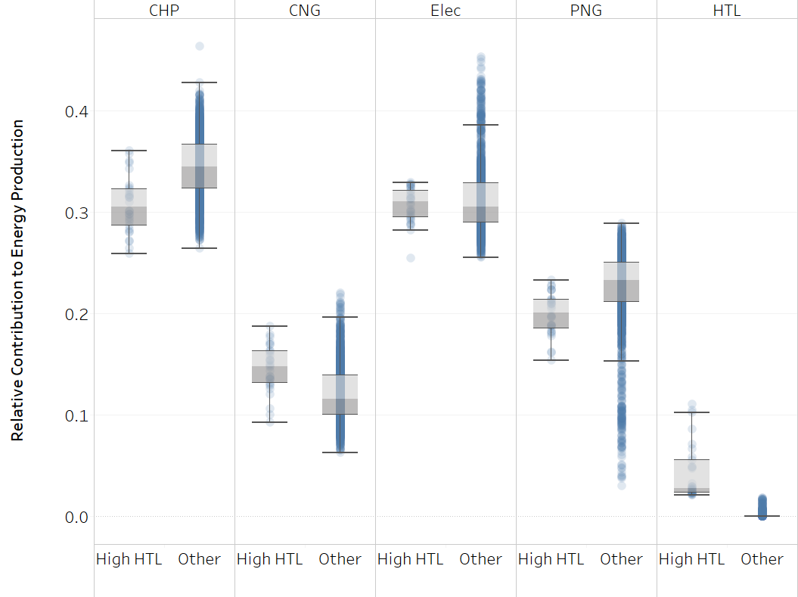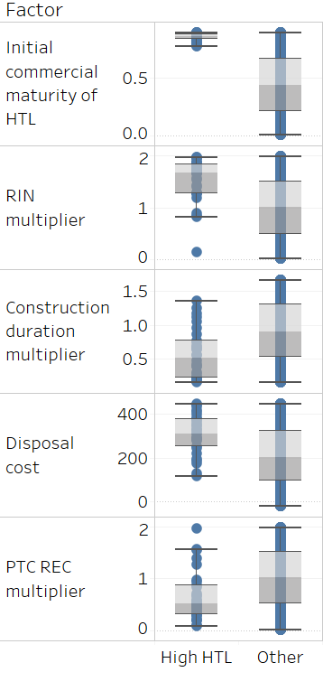

**Figure 4. Simulations where HTL contributes to more than 2% of total energy production (labeled High HTL) have lower production of CHP and PNG and higher production of CNG than cases where HTL produces less than or equal to 2% of total energy (labeled Other).** Each vertical line consists dots, each of which represents a single simulation from a 1% sample of the simulation results. The gray shading shows the middle two quartiles, with the median falling on the dividing line between the two shades. The other two bars show the 5th and 95th percentiles. The left panel shows the relative contribution to total energy; the right panel indicates how the distribution of factor values varies between the High HTL and Other cases.

**Insight #6. Based on the limited factors and ranges explored, this study did not find evidence of inter-regional policy impacts on growth in HTL production.**

One initial hypothesis was that regional policies in California might be important to overall growth in HTL production. California policies (LCFS, SB1383) did not rank among those explaining 5% or more of the variance along with other factors.

**Conclusions**

This exploration of the impact of twelve model factors on the adoption of HTL as a WTE technology choice found specific conditions in which HTL gains modest production at CAFOs and POTWs in California and the rest of the United States. This analysis informs WTE technology selection at an opportune moment because most at CAFOs and POTWs do not have WTE and HTL, despite its pre-commercial status, offers certain technical advantages relative to other candidate technologies. WTE projects are sited over 350 CAFOs and POTWs, a minority of the total facilities, and the technologies used to date (CNG, CHP, electricity, PNG) are favored for selection at the remaining sites. Even so, we have identified scenarios under which HTL achieves modest levels of adoption. WTE technology choice differs from biofuels industry technology choice because waste disposal is obligatory for WTE, but not necessarily required for biofuel production, and fuel production is a secondary objective for CAFOs and POTWs but a primary one for biofuel producers.

The results of this analysis of key factors for HTL production indicate a narrow set of conditions that lead to higher HTL production. These conditions target HTL specifically by increasing the initial commercial maturity for HTL, and also shape background conditions that affect other WTE pathways to favor HTL relative to the others. The direct increase in initial commercial maturity of HTL results in the greatest gains for that technology. Considering the background conditions, there is a tradeoff between maximizing total energy produced via WTE and total energy produced via HTL, because of the relative immaturity of HTL and competition with other technologies. The highest-ranking factor that is important for HTL production is its initial commercial maturity, indicating the paramount importance of greater technology maturity. The ranking of factors that are most important for HTL production is different from the ranking of factors most important for total energy production, with PTC REC values ranking most important for total energy due to the large predominance of electricity production from landfill gas.